**DevSecOps**

**Daily Tasks**

* **raghudevopsb83**: <https://github.com/raghudevopsb83>
* Killercoda: <https://killercoda.com/rkalluru>
* Miro Link: <https://miro.com/app/board/uXjVLpuNJUc=/?share_link_id=887788532350>
* AWS Login Page: <https://us-east-1.console.aws.amazon.com/console/home?region=us-east-1>
* Project link: <https://learndevopsonline.github.io/learndevopsonline/build/docs/category/roboshop-project-setup-documentation---rhel-9/>
* Lab: <https://learndevopsonline.my.canva.site/lab-help>

**Important Commands**

* Sudo set-prompt frontend : setting the prompt to be frontend.
* Dnf list all | grep nginx : list all nginx instances
* netstat -lntp : see active connections.
* Sed -i ‘s|127.0.0.0|0.0.0.0|’ /etc/mongod.conf : to replace 127.0.0.0 with 0.0.0.0 from command line using ‘sed’ command
* sudo ls -Ra /home/ : Lists all subfolders in directories.
* Systemd service file sample
* Tail /var/log/messages
* Dynamic tail: tail -f
* Processes check:

* + Whole system processes:

* + More details:

* + Force kill process:



* Checking user:

* List of installed packages:

* + Available for installation:



* + Available/Installed packages: @ indicates installed

* + Check module list:

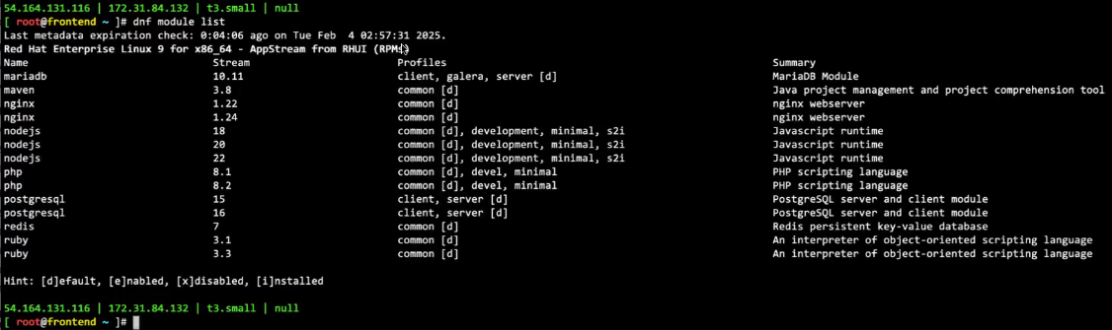

* + Enabling/disabling module:

* Downloading and naming a file:



* List all the running services:



* Change ownership:

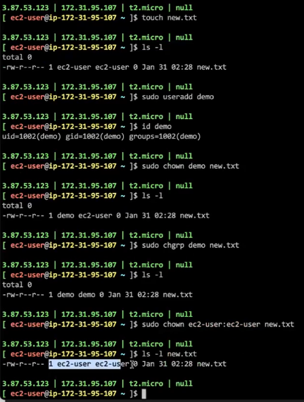

* Changing permission using chmod:

* To find router ip address:

* Starting service and checking the port:

* + Including processes:

